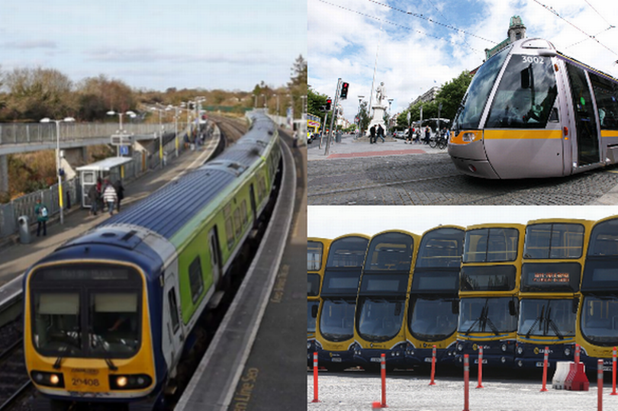

October, 2018

Keith Feeney

15015556

BSHCSD4

Evalution of public transport apps

Multimedia & Mobile Application Development

Cover image: (Irish Mirror, 2016)

Contents

Acronyms 1

Introduction 2

Evaluation 2

Dublin Bus 2

Users’ Evaluation 2

Personal Evaluation 2

Screenshots 4

Real Time Info 8

Evaluation 8

Screenshots 9

Real Time Ireland (NTA) 11

Users’ Evaluation 11

Personal Evaluation 12

Screenshots 13

Recommendations 17

Conclusion 17

References 18

# Acronyms

|  |  |
| --- | --- |
| App(s) | - Mobile application(s) |
| Real Time Ireland (NTA | - Real Time Ireland app by the National Transport Authority |
| Real Time Info (TJ) | - Real Time Info app by Tattooed Joey |
| UI | - User interface |
| RTI | - Real time information (page) / departure page |

# Introduction

This report looks at three different Android apps relating to public transport in Ireland, specifically in the Dublin region. The apps that this report will look at are the official Dublin Bus app by Dublin Bus, Real Time Ireland (NTA) and Real Time Info (TJ). We will evaluate these apps from a user perspective and from a personal perspective as well as discuss the major positives and negatives regarding each app. Later, this report will look at recommendations on how to create an app with the known issues mentioned as well as some additional features to improve the app.

# Evaluation

## Dublin Bus

### Users’ Evaluation

At the time of writing this, the official Dublin Bus app has been removed from the Google Play Store. A representative of Dublin Bus have said they are having issues with this and are working to fix this. (Dublin Bus, 2018) For the time being, we will discuss the comments on the official Dublin Bus app on the Apple App Store. The Apple app has a very low score of just 38%[1]. Some of the users say that the real-time information is inaccurate, with “ghost busses” where a due bus would not show or the app would have the RTI delayed excessively. (Apple; i3 Digital; Dublin Bus; Biznet IIS Ltd, 2016)

A one-star reviewer states that the app is not good for planning a route and they suggest using other apps and that the UI “was not priority” with the development team. A user who rated four stars says that the app is overall good but the layout is very much out of date. This could be a result of the app not been updated in two years. (Apple; i3 Digital; Dublin Bus; Biznet IIS Ltd, 2016)

### Personal Evaluation

As someone who uses Dublin Bus on a daily basis, it works OK. In general terms, the app works, does what it says, but it’s felt the app becomes slow to respond, especially during morning and evening rush hour. There was “four million” Dublin Bus users in 2014. (Hosford, 2015) That’s an average of just under 11,000 daily users. This could contribute to why the app’s responsiveness is slow.

Some major issues with the app are that if a route is changed, for example, the 27 from Clare Hall to Eden Quay is the 27C, but the app sometimes displays this as the 27 to Jobstown, which is incorrect. The app also does not show buses that have been cancelled for whatever reason.

Some good points on the app are that timetables are available, albeit this just being a normal website page on the Dublin Bus website instead of being integrated into the app. The app can also search for routes, or stop numbers by the stop ID number or address. Another good point is that status messages are displayed when viewing a stop, if a status is available. This does not occur in the Real Time Ireland (NTA). Some other positives include; search a stop nearby on a map, search a route and look at all of its stops, a fare calculator and news information.

Overall, the bare bones of the app work like they should, even with minor issues. The layout of the app in comparison to Dublin Bus’s social media artwork is extremely outdated. Some of the screenshots show this.

### Screenshots

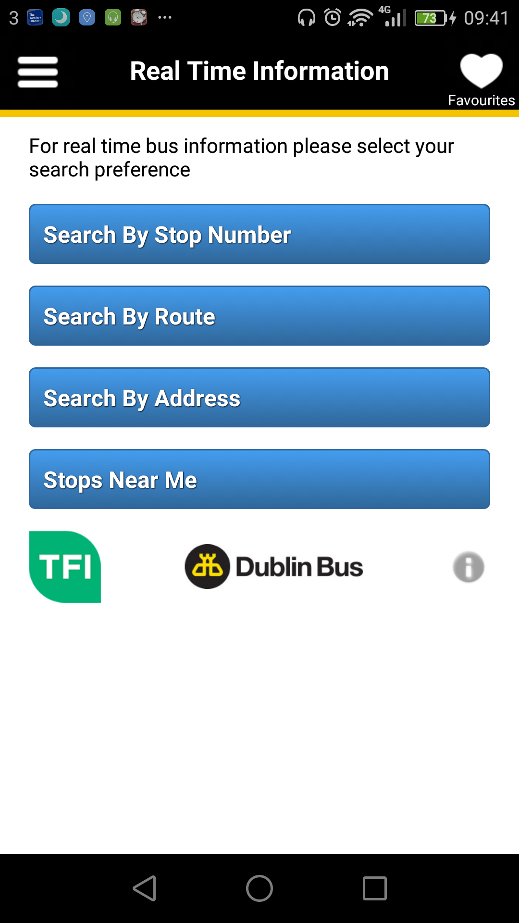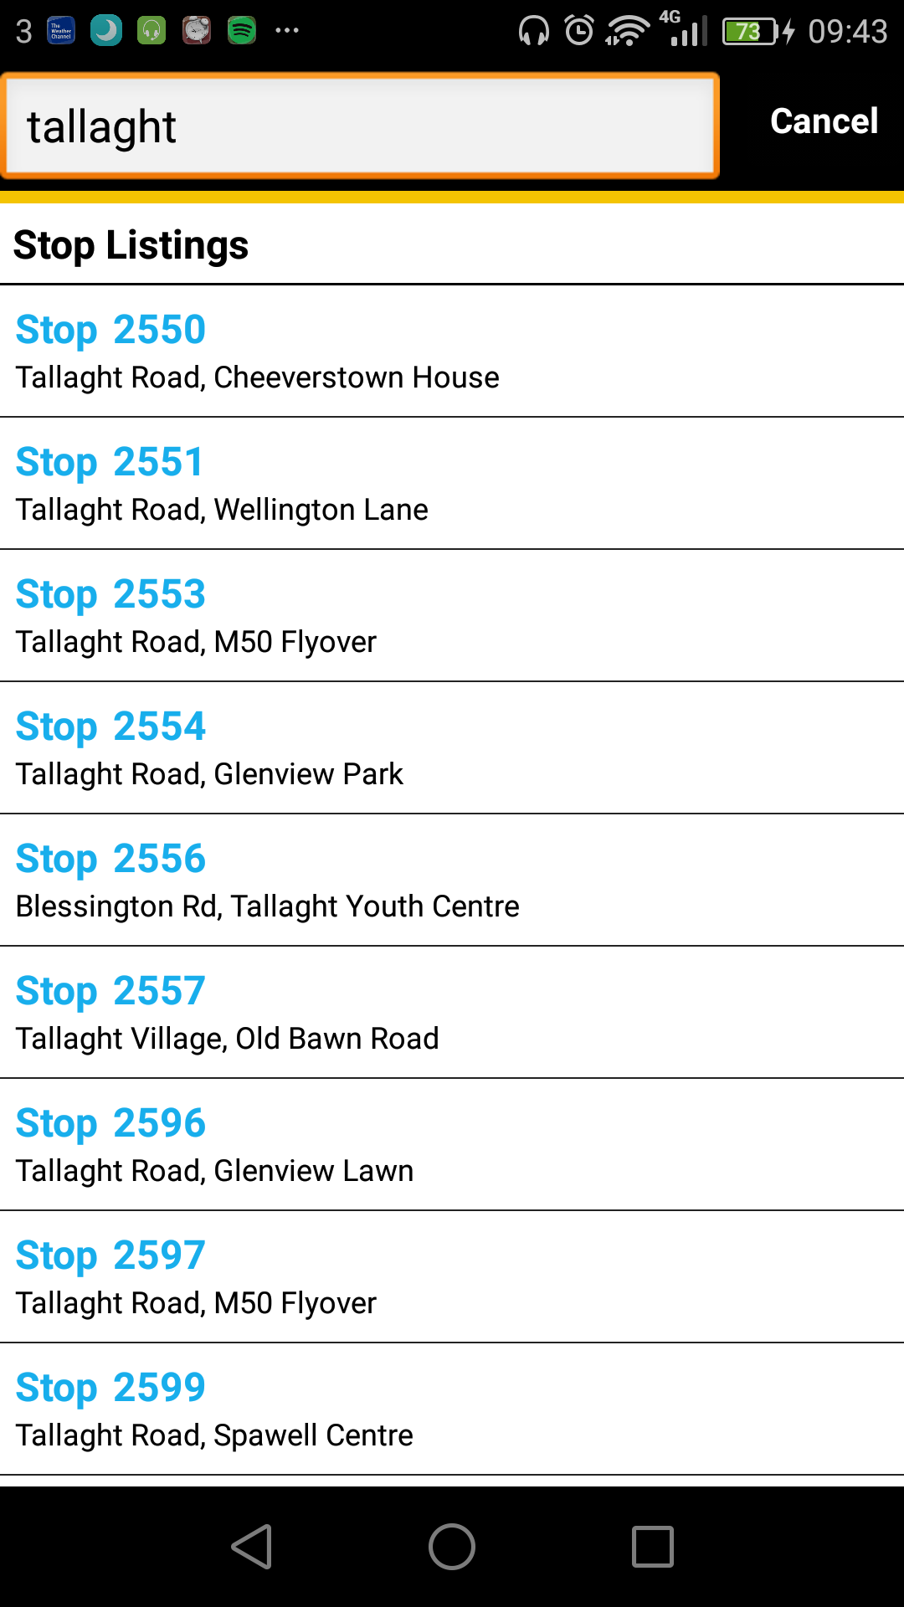

|  |  |
| --- | --- |
| Main Page | When searching a stop by its address |

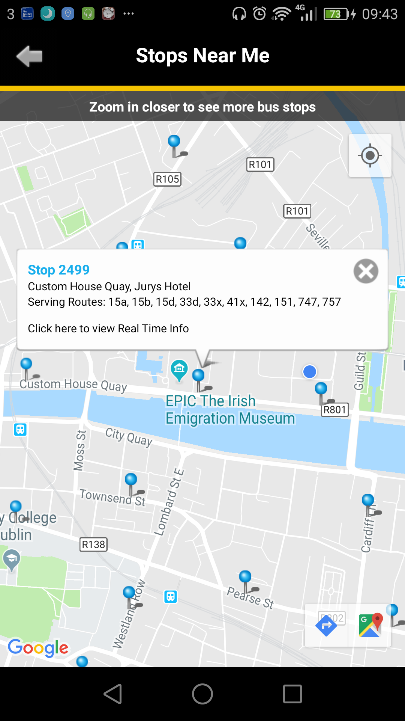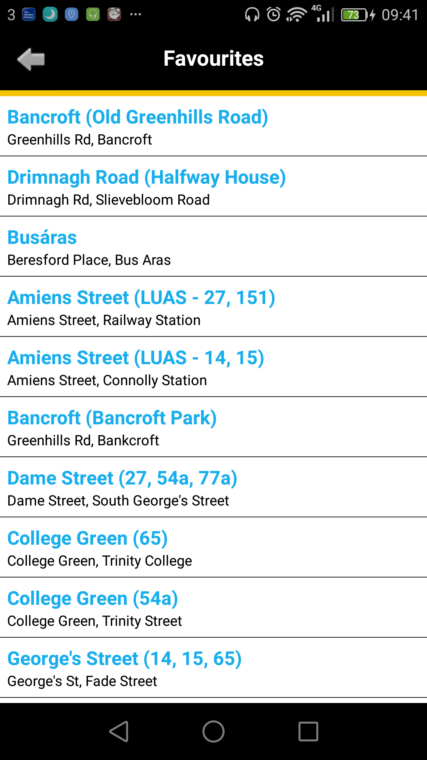

|  |  |
| --- | --- |
| Stops nearby and a stop tapped | Favourites page |

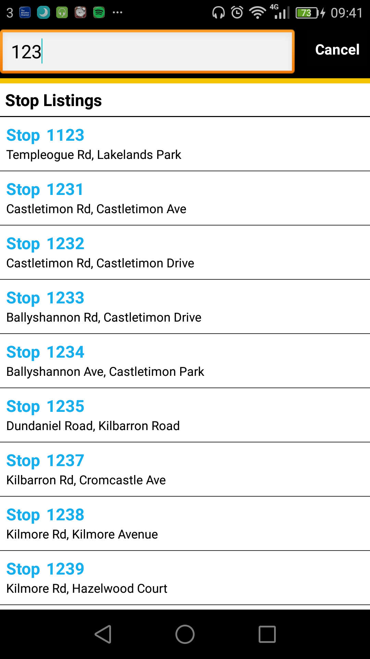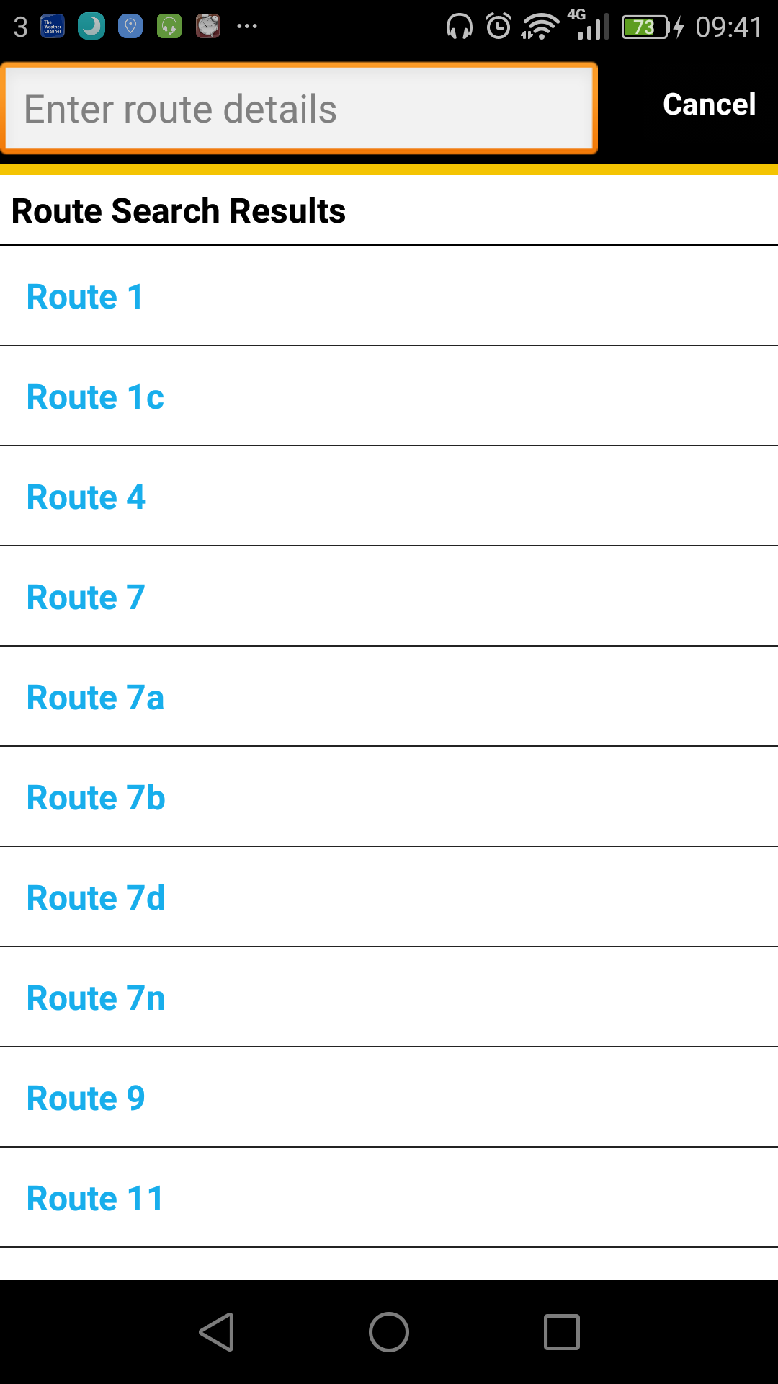

Searching stop by stop number List of all routes, searchable

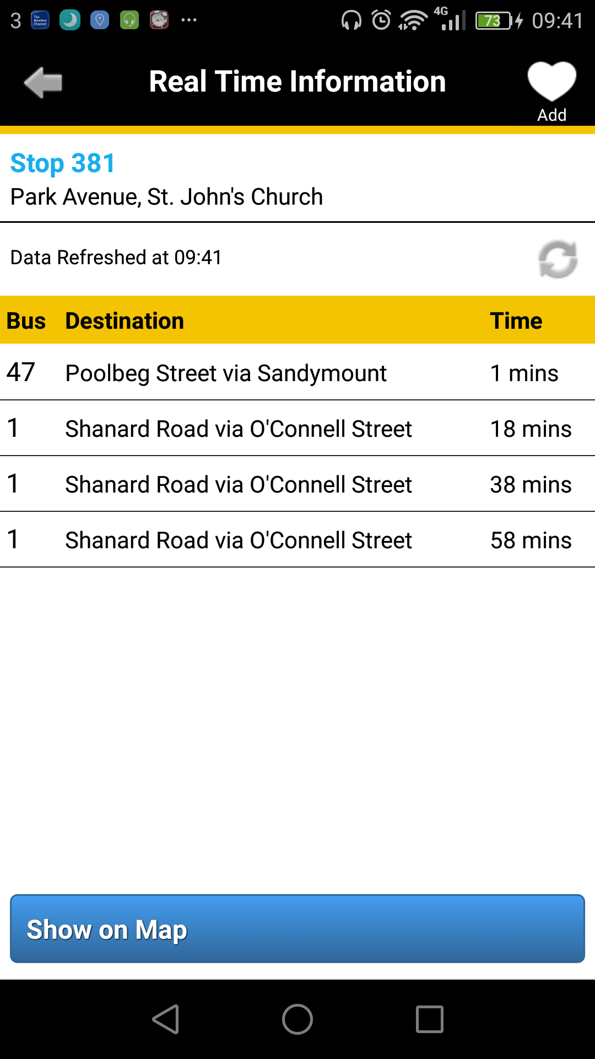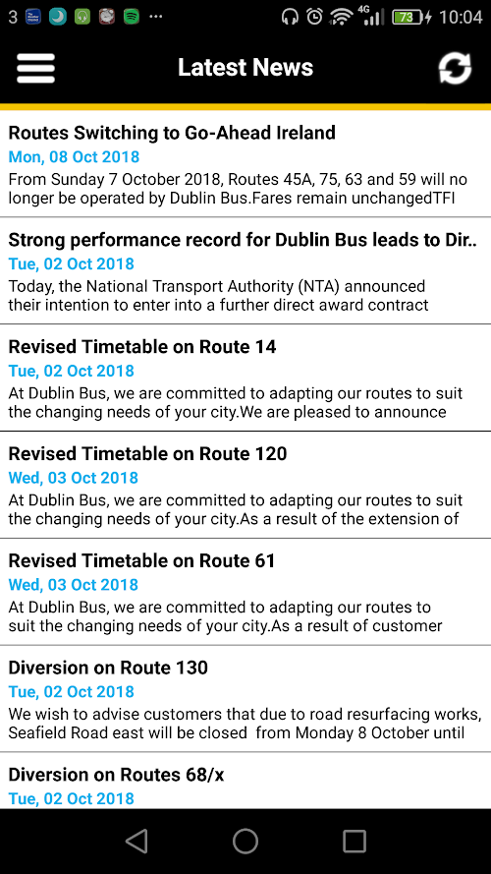

|  |  |
| --- | --- |
| Example of RTI page | News page |

Screenshots of Dublin Bus app: (Dublin Bus, 2018)

## Real Time Info

Real Time Info (TJ) is a new app that does not have any reviews. It was decided to talk about this app as the writer of this report created it. The premise is that Real Time Info (TJ) is a web page within an app. The webpage points to RTPI.ie, where the RTI is provided as text only

### Evaluation

With no graphics, the app’s UI is not pleasant. It’s bland and drab. When the back button is pressed in the app, it exits the app. This was a design flaw that was not corrected. There is a feature where the user pulls down the screen to refresh the page, it refreshes back to the start page. Another design flaw. The purpose of the app was to see how to publish an app on the Google Play Store. It was more difficult than what was expected. Major disappointments about this app include having no timetables, seemingly very clunky and thrown together (Note: it was).

Some positives about this app are; if other apps like Dublin Bus or Real Time Ireland (NTA) are not working, this app will always work. Another positive feature is that when a bus is cancelled, the app says this. Writing this, Go-Ahead has obtained routes from Dublin Bus for a number of days, but the Real Time Ireland (NTA) is not displaying the RTI for Go-Ahead Ireland routes yet. But with this app, they are. Also, status messages are shown in the r

Overall, this app works perfectly on the website side and the information provided is accurate and up to date with new services. But has minor issues within the app’s infrastructure.

### Screenshots

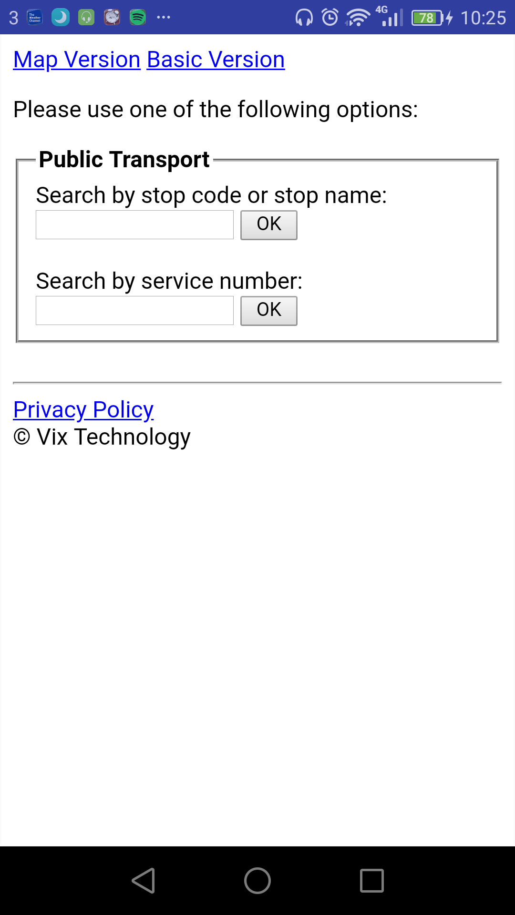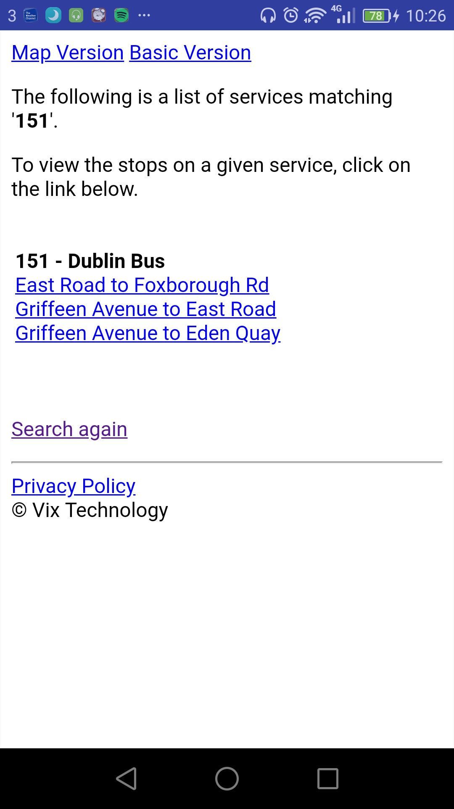

|  |  |
| --- | --- |
| Main Page | Searching 151 in service number field |

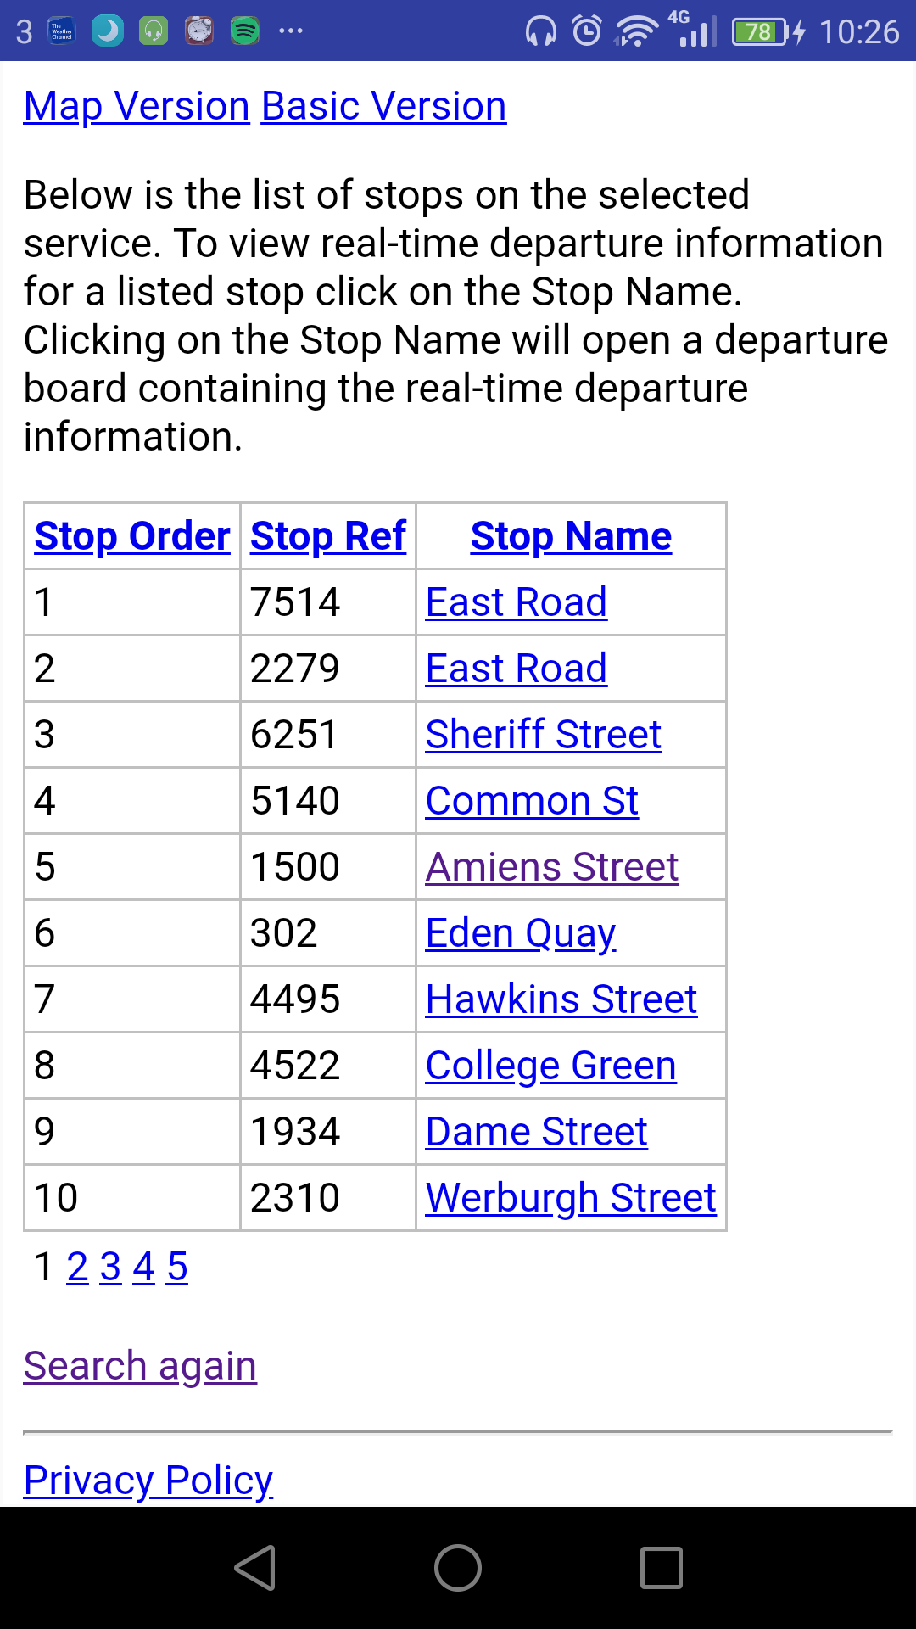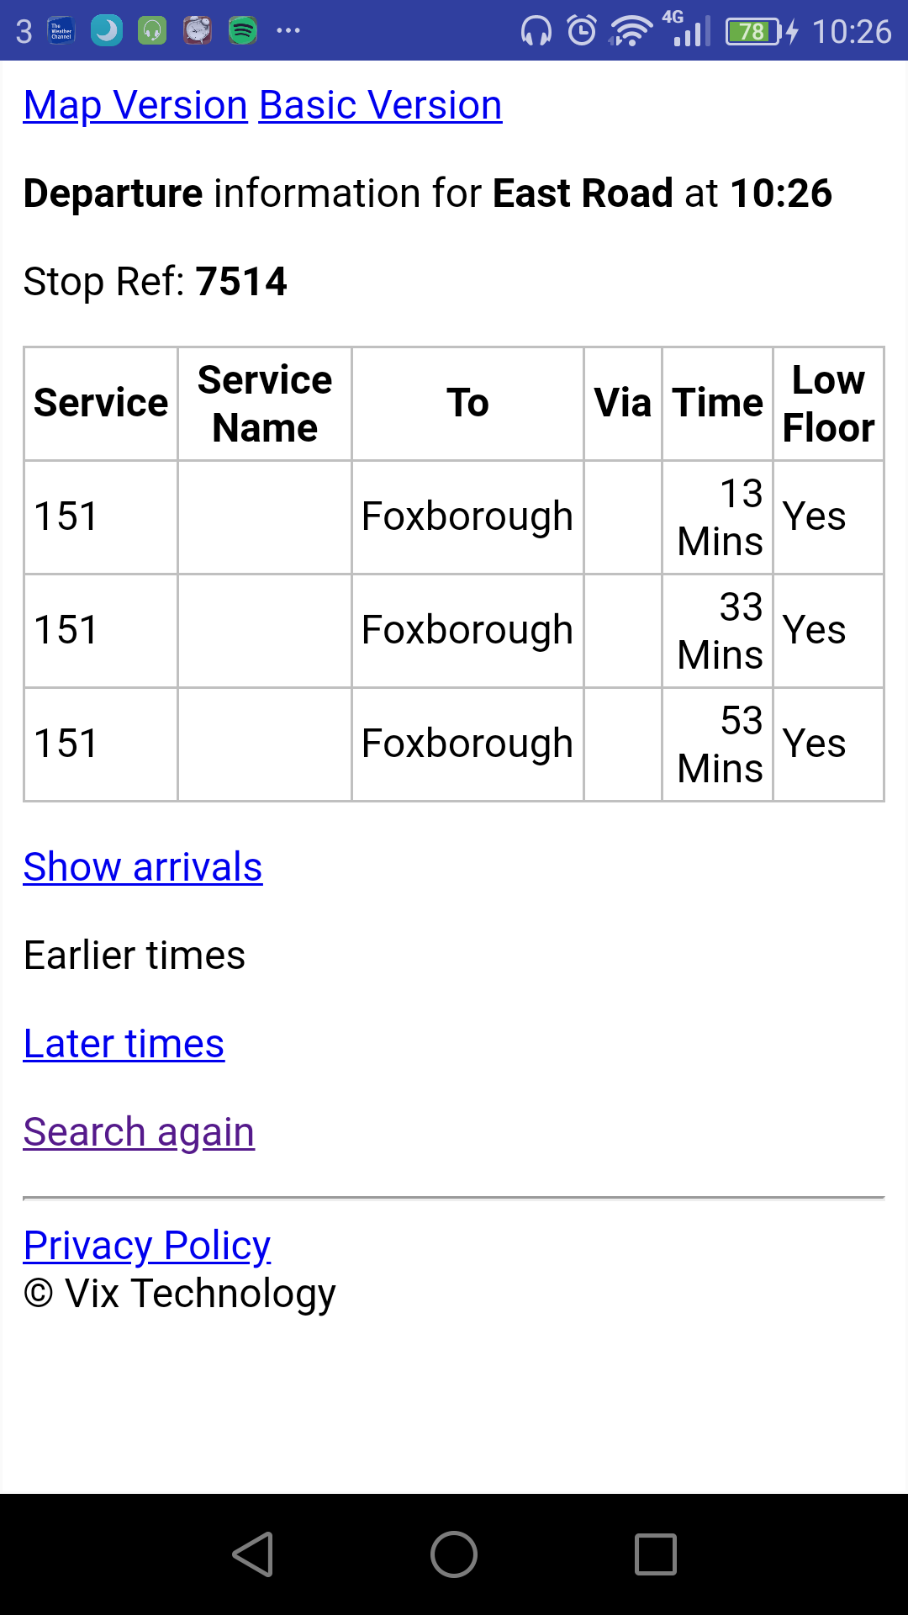

|  |  |
| --- | --- |
| List of 151 stops outbound | RTI page of stop 7514 |

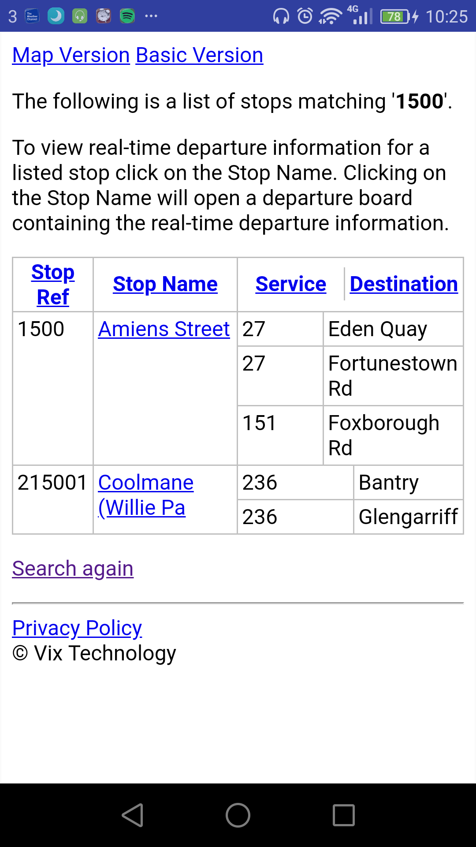

|  |  |
| --- | --- |
| Searching stop number 1500 |  |

Screenshots of Real Time Info: (Vix Technology; Tattooed Joey, 2018)

## Real Time Ireland (NTA)

### Users’ Evaluation

Similarly, with the Dublin Bus app, users are saying that the RTI is inaccurate and unreliable. However, it’s fairing much better than Dublin Bus, with a rating of 60%1. Some users have also said that when they save a stop into their favourites, it gets removed when the app is re-opened, as well as draining the battery quickly in comparison with older versions. (Google; National Transport Authority, 2018)

With this app, unlike the Dublin Bus and Real Time Info (TJ) apps, alerts can be set up to say when a bus is due or when a stop is near. For example, one could set an alert for when a bus is due at a stop in 15 minutes or when they near the stop they wish to depart the bus at. However, it seems the functionality of this is not the best, according to some of the reviews and that it’s “buggy”. Some of the users have said that the app is a little slow, even when on a high speed Wi-Fi or mobile data network. (Google; National Transport Authority, 2018)

n regards to the UI, the users who have posted reviews seem rather happy with it and that is looks modern and fresh, and that it’s easy to navigate within the app. (Google; National Transport Authority, 2018)

### Personal Evaluation

The UI looks clean, modern and is pretty easy to navigate through. While using the app, it wasn’t particularly slow. It feels robust and that it can’t be broken easily. Using this app instead of the Dublin Bus app for the past few days, the slowness was there at rush hours, but the slowness was not as bad as the Dublin Bus app. The map above the RTI is a nice feature. The route maps felt pointless, it was not easy to grasp why they were included within the app.

The one major downside that is with the app, is that the news articles. Even though they are from multiple providers, they are up to a week old. Dublin Bus posted a news article on their app within the last few days, but it’s not showing in this app. It has much potential. Another thing is that the journey planner is a separate app. One needs to install this other app while Dublin Bus have it included in their app. Not good. There’s no status messages at all on this app which can be troublesome for some people.

Overall good, but the news articles are a disappointment.

### Screenshots

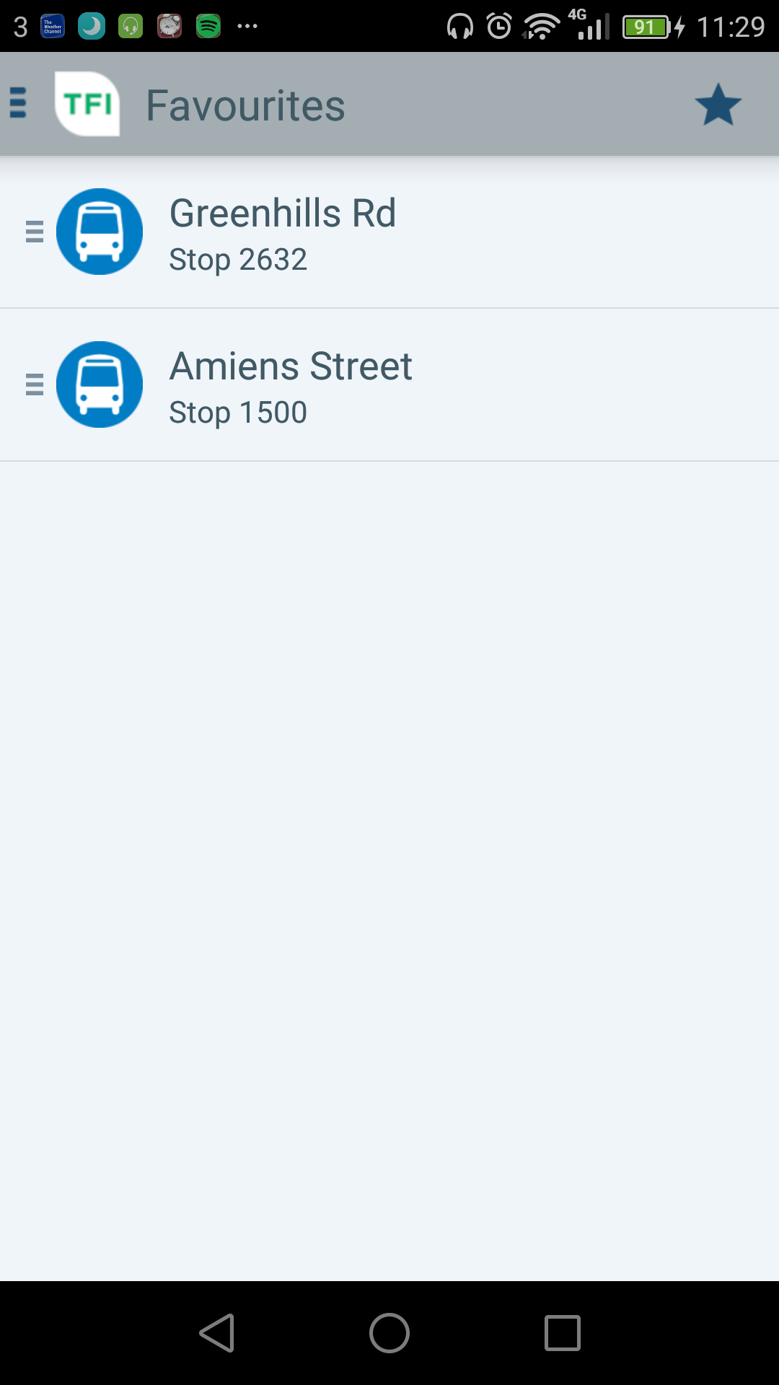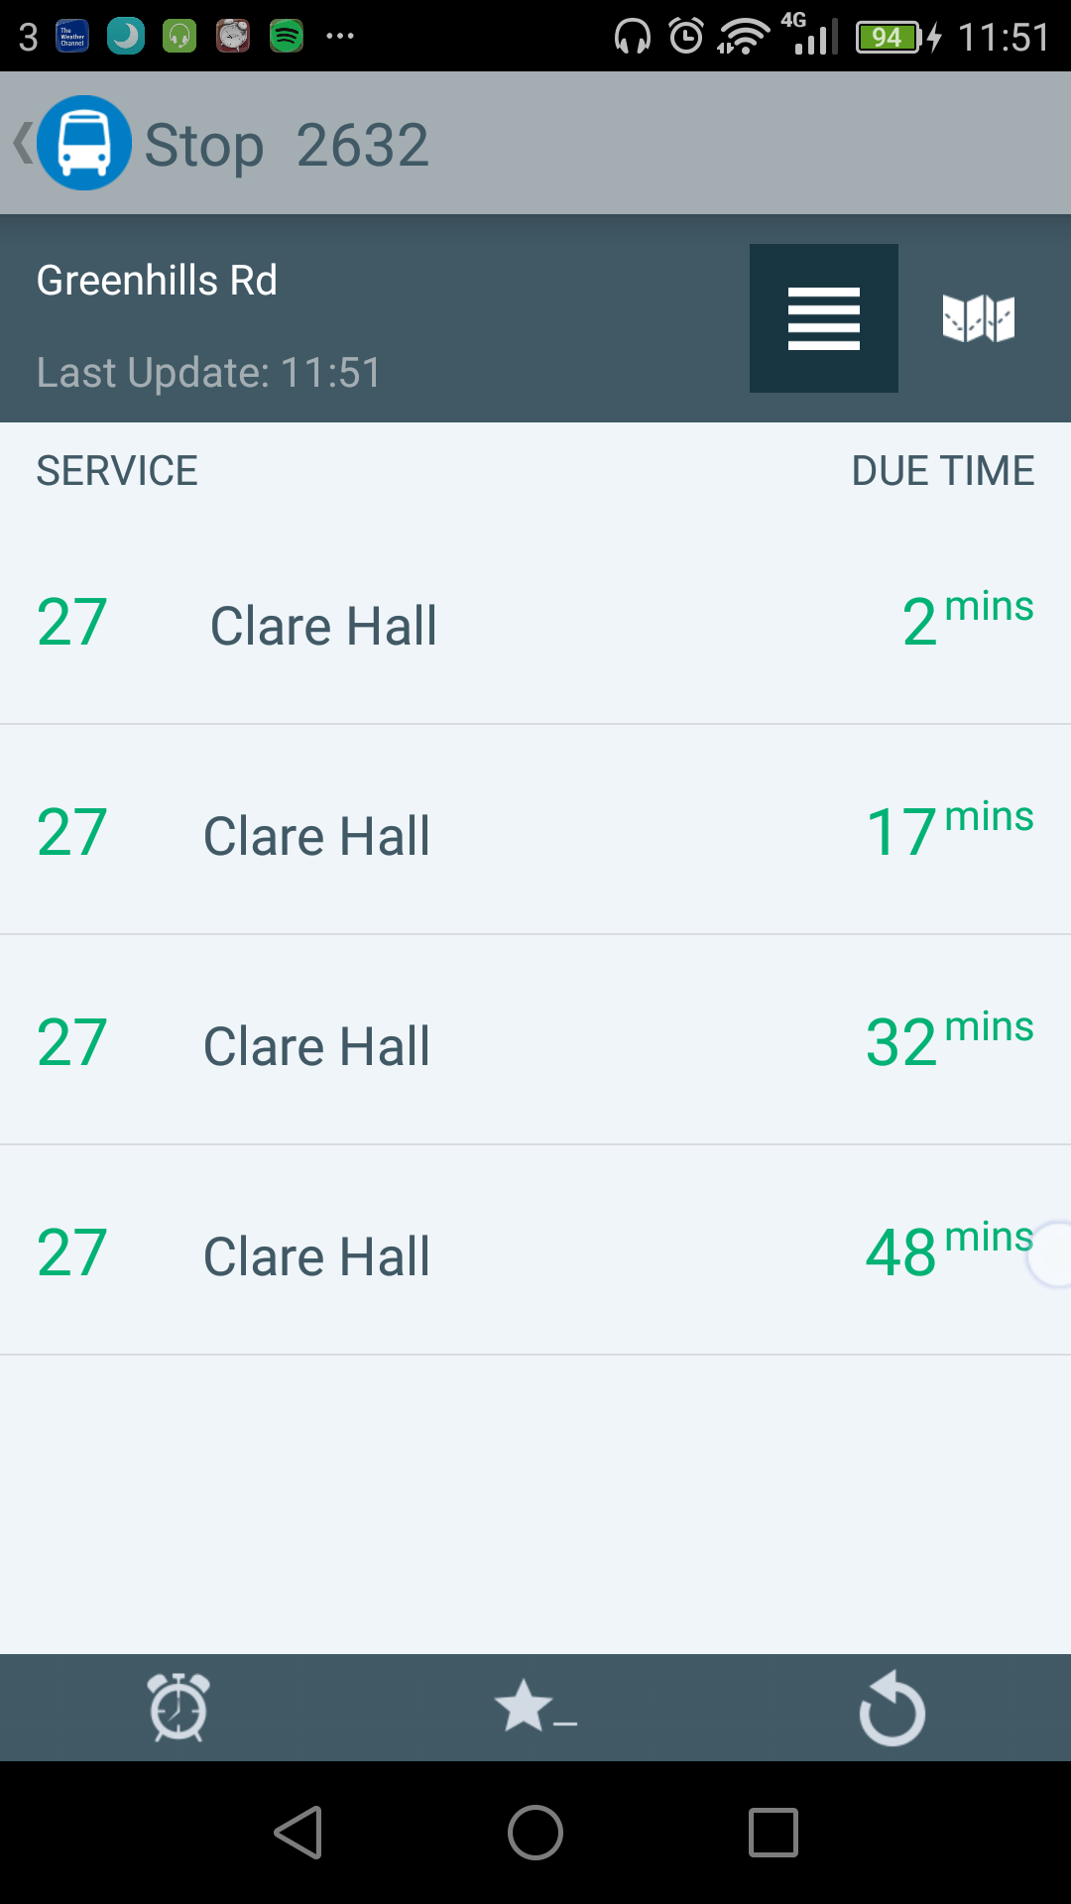

|  |  |
| --- | --- |
| Favourites are opened first | RTI page of stop number 2632 |

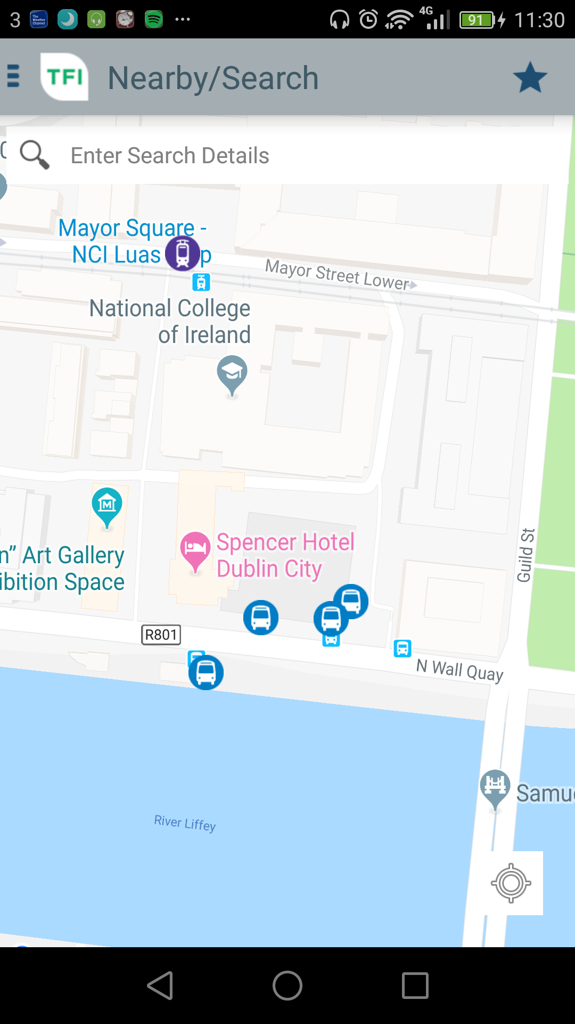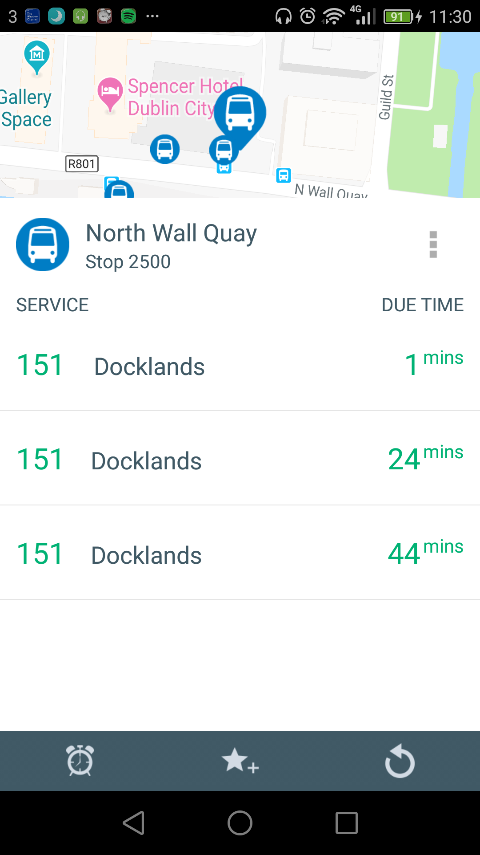

|  |  |
| --- | --- |
| The Nearby/Search map | When a stop is tapped in the map |

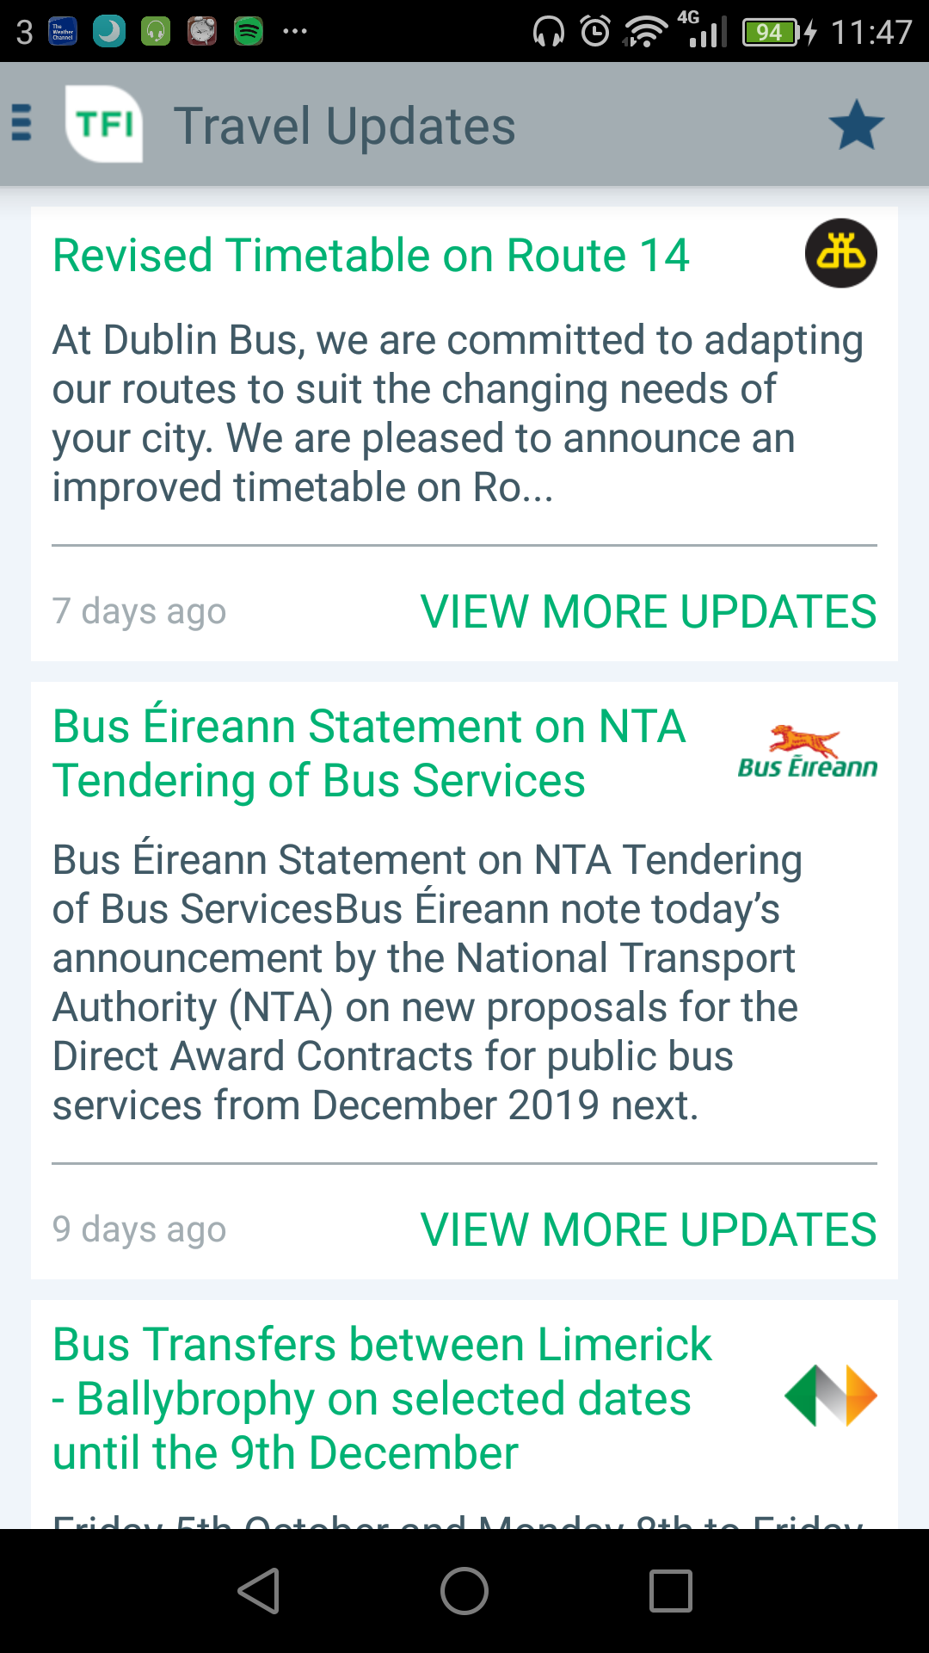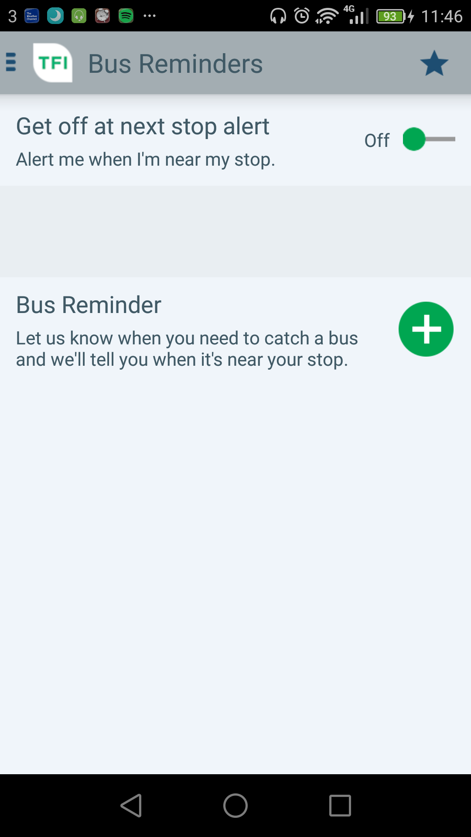

|  |  |
| --- | --- |
| Main news page | Reminders page |

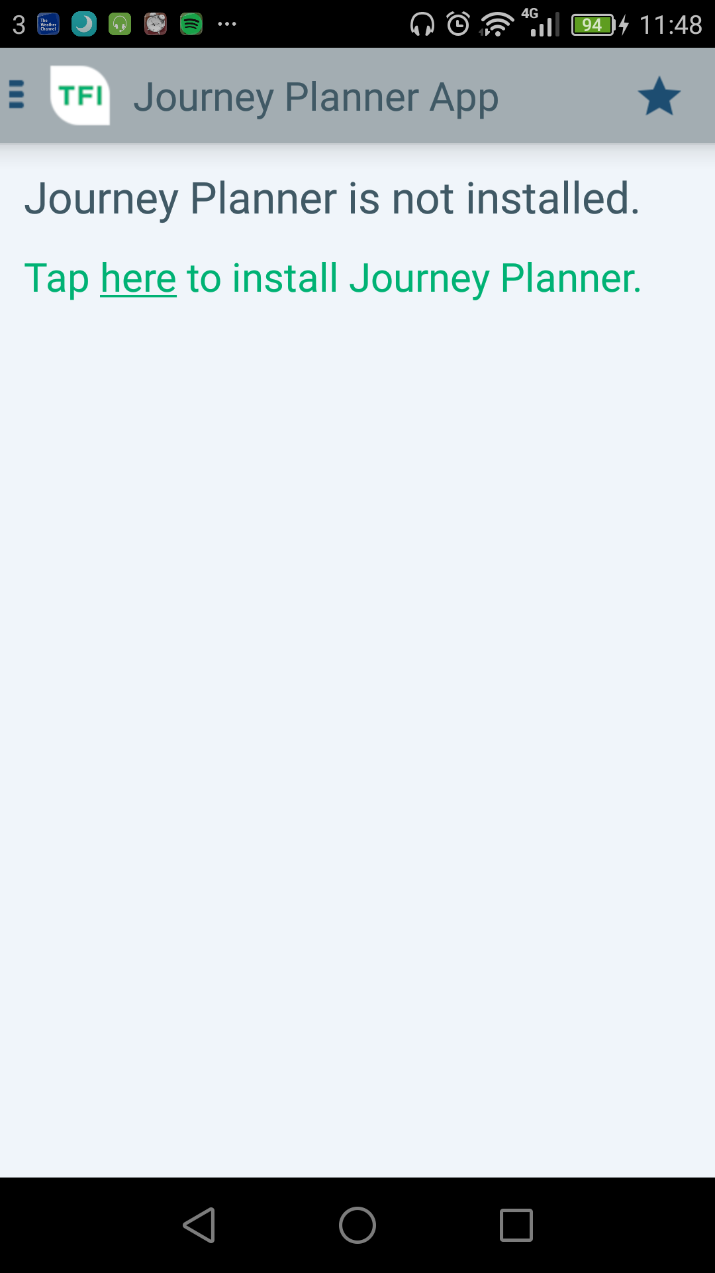

|  |  |
| --- | --- |
| Journey Planner page |  |

Real Time Ireland screenshots: (National Transport Authority, 2018)

# Recommendations

One very clear issue that was persistent through researching is that the RTI can be inaccurate. Unfortunately, it would not be possible to fix this when creating a new app, as the RTI is provided from an external source, such as the National Transport of Ireland’s and Dublin Bus’s web services.

Issues than can be fixed:

- Bus timetables from within the app and not have them as an external webpage.

- UI navigation simplified and beautified.

- Storage of information such as Favourites correctly on device

- News being updated on a regular basis, with the possibility of an alert of a new news article.

- Searching could be improved, especially in the Dublin Bus and Real Time Info (TJ) apps.

- Removal of route maps. A link to these on a website would suffice instead of taking up memory within the app.

Possible further development:

- Link to contact service providers as this was not present in either of the apps.

- Possibility of having the Twitter feeds of service providers in the app, so users can keep really up to date, but kept to the last 10 posts to avoid memory issues.

- Traffic information

- alert to notify user that traffic is busy on their favourite routes.

- Expanding into other transport providers like LUAS, train and also outside Dublin

# Conclusion

This report looked at Android apps relating to public transport in Ireland, with specific attention to apps within Dublin. The three apps we looked at are Dublin Bus, Real Time Info (TJ) and Real Time Ireland (NTA). We discussed the major key points, the positives and negatives of these apps and what users had to say in the reviews. We also looked at these from a personal view. Furthermore, we looked at some ideas for how these apps could be improved by fixing what is wrong with these apps as well as looking at how to develop the app further.

# References

Irish Mirror, (2016), *Luas, Dart, and Dublin Bus* [Online]  
Available at: https://www.irishmirror.ie/news/irish-news/dublin-bus-fares-highest-europe-7702147

[Accessed 11 October 2018].

Dublin Bus, (2018), *Screenshots* [Image][Accessed 11 October 2018].

Vix Technology; Tattooed Joey, (2018), *Screenshots* [Image][Accessed 11 October 2018].

National Transport Authority, (2018), *Screenshots* [Image][Accessed 11 October 2018].

Apple; i3 Digital; Dublin Bus; Biznet IIS Ltd, 2016. *App Store Preview: Dublin Bus.* [Online]   
Available at: https://itunes.apple.com/ie/app/dublin-bus/id450455266?mt=8  
[Accessed 11 October 2018].

Dublin Bus, 2018. *Facebook message* [Interview] (11 October 2018).

Google; National Transport Authority, 2018. *Real Time Ireland.* [Online]   
Available at: https://play.google.com/store/apps/details?id=com.osds.rtpi  
[Accessed 11 October 2018].

Hosford, P., 2015. *How many journeys were there on Dublin Bus last year?.* [Online]   
Available at: http://www.thejournal.ie/dublin-bus-journeys-in-2014-1882436-Jan2015/  
[Accessed 11 October 2018].

1. 0% being the worst, 100% being the best.